CHAPTER – I

Introduction

Chapter – I:

Introduction

Intracranial hemorrhage (ICH) is a critical medical condition characterized by bleeding within the brain tissue, which can result from various causes such as trauma, vascular abnormalities, or underlying medical conditions. Timely and accurate diagnosis of intracranial hemorrhage is crucial for effective medical intervention and improved patient outcomes. Image analysis techniques, particularly Convolutional Neural Networks (CNNs), have emerged as powerful tools in the field of medical imaging for the detection and classification of intracranial hemorrhage.

### 1.1 Background

Traditional methods of diagnosing intracranial hemorrhage involve the analysis of medical images such as computed tomography (CT) scans or magnetic resonance imaging (MRI). However, the manual interpretation of these images can be time-consuming and may vary in accuracy among different practitioners. CNNs, a type of deep learning architecture, have shown promise in automating the process of image analysis, enabling faster and more consistent identification of intracranial hemorrhage.

### 1.2. Convolutional Neural Networks (CNNs)

CNNs are a class of deep neural networks designed for image recognition and analysis. They are particularly well-suited for tasks involving spatial hierarchies and local patterns, making them an ideal choice for medical image analysis. The network architecture includes convolutional layers that learn hierarchical features from input images, pooling layers for dimensionality reduction, and fully connected layers for classification.

### 1.3. Challenges in Intracranial Hemorrhage Detection

Detecting intracranial hemorrhage from medical images poses several challenges. The subtle nature of early hemorrhages, variations in imaging protocols, and the presence of anatomical structures can make accurate identification challenging. CNNs address these challenges by automatically learning relevant features from large datasets, improving their ability to generalize across diverse cases.

### 1.4. Data Preprocessing

Large and diverse datasets are crucial for training robust CNN models. Data preprocessing techniques, such as normalization, augmentation, and balancing, are applied to enhance the network's performance and reduce the risk of overfitting.

### 1.5. Model Training and Validation

The CNN model is trained on labeled datasets, learning to differentiate between normal brain tissue and various types of intracranial hemorrhages. Training involves optimizing the model parameters using backpropagation and gradient descent. The trained model is then validated on separate datasets to ensure its generalizability to new, unseen cases.

### 1.6. Model Interpretability

Understanding how the CNN arrives at its decisions is essential for gaining trust in the diagnostic process. Techniques such as heatmap visualization and attention mechanisms help highlight regions of interest within the images, providing insights into the model's decision-making process.

### 1.7. Clinical Implications

The integration of CNN-based image analysis in clinical settings has the potential to expedite the detection of intracranial hemorrhage, leading to faster decision-making and improved patient outcomes. However, the deployment of these technologies requires careful consideration of ethical, regulatory, and interpretability aspects.

As these technologies continue to evolve, collaboration between medical professionals, data scientists, and ethicists becomes increasingly important to ensure their responsible and effective implementation in clinical practice

**Chapter 2. Review of Related Work**

This chapter deals with the survey on the methodologies adopted for the association of documents using a headword extraction algorithm. This chapter also deals with a brief analysis of the tools used for the enhancement, segmentation design development, and geometric transformation.

**Chapter 3. Problem Identification**

This chapter deals with the identification of the problem due to which we reached the solution and thought that this project helped in resolving the problem to an extinct.

**Chapter 4. Proposed Methodology**

This chapter deals with the methodology and techniques used in building the project with a proper workflow diagram.

**Chapter 5. Implementation**

In this chapter, we have explained the implantation part and also shown copies of the result as given by the model.

**Chapter 6. Result & Discussion**

Here we mentioned the result and gave a brief discussion on we are solving the problem with result accuracies.

**Chapter 7. Conclusion & Future Scope**

This chapter deals with the conclusion of whether the problem is actually resolved or not and how much we can improve it further and also adds the future scope of what we can add to enhance its performance.

CHAPTER – II

LITERATURE REVIEW

Chapter II:

literature review

**2.1 Paper Reviewed**

Traumatic Brain Injury (TBI) stands as a significant public health concern in the United States, contributing substantially to both mortality and disability rates. According to the 2013 census, TBI accounted for approximately 30% of all injury-related deaths in the country, emphasizing its gravity. Among the potential complications arising from TBI, intracranial injuries and fractures present the highest ratio of mortality. Of particular concern is Intracranial Hemorrhage (ICH), a condition that, if not treated accurately, can lead to severe consequences such as whole-body paralysis or death.

In emergency scenarios involving TBI patients, Computed Tomography (CT) scans play a pivotal role in evaluation. These scans provide detailed insights into the extent of injuries, with a specific focus on conditions like brain hemorrhage. The ability to capture multiple layers of the brain makes CT scans an indispensable tool for diagnosing and understanding the severity of traumatic brain injuries.

The advent of Internet of Things (IoT) technologies in healthcare has ushered in a new era of possibilities. These technologies offer continuous monitoring and diagnostic capabilities, reducing the need for patients to endure lengthy waits in hospitals. IoT-based healthcare applications have been developed to address various medical needs, ranging from cancer care to continuous glucose monitoring. The integration of IoT with neural networks, especially deep learning models, opens up avenues for the development of automated tools for the screening and diagnosis of conditions like ICH.

As healthcare becomes more interconnected, the potential benefits of IoT are evident. The ability to remotely monitor and diagnose patients not only enhances efficiency but also has the potential to save lives, particularly in emergency situations. The marriage of IoT with neural networks, known for their prowess in image classification tasks, offers a promising solution for the automation of ICH screening. This is especially crucial in scenarios where immediate expert intervention might not be readily available, such as in emergency rooms in developing countries.

The intersection of IoT and healthcare is not without its challenges. Privacy concerns, data security, and interoperability issues must be carefully addressed to ensure the ethical and secure deployment of these technologies. Additionally, the reliance on CT scans and other imaging modalities raises questions about the radiation exposure associated with these diagnostic tools. Balancing the benefits of rapid and accurate diagnosis with potential risks is a critical consideration.

**2.2Summary**

In the present chapter, the literature survey made so far related to the work has been briefly discussed.

|  |  |  |  |  |
| --- | --- | --- | --- | --- |
| **S**.**no** | **Year** | **Paper Title** | **Journals** | **Research Finding** |
| 1. | 2023 | A novel machine learning-based feature extraction method for classifying intracranial hemorrhage computed tomography image | ELSEVIER | This study explored the classification of intracranial hemorrhage CT images using machine learning. A novel joint feature-based method, combining texture-based GLCM and transform features, outperformed standalone approaches. Wavelet transform, compressing images more effectively than cosine transform, contributed to optimal feature extraction. The proposed joint feature approach, specifically employing cosine with GLCM and wavelet with GLCM, demonstrated superior accuracy. The Random Forest classifier achieved the highest classification accuracy of 87.22 percent using the wavelet transform with the GLCM joint feature group. Overall, the joint feature-based technique surpassed both texture-based and transform-based methods, highlighting its potential for improved categorization in sizable datasets. |
| 2. | 2020 | A Smart Machine Learning Model for the Detection of Brain Hemorrhage Diagnosis Based Internet of Things in Smart Cities | WILEY Hindawi | This paper proposes an IoT-based smart brain hemorrhage detection system using machine learning techniques. The IoT application utilizes a generalized feedforward neural network with an input layer, hidden layer, and output layer. The proposed model's accuracy for detecting brain hemorrhage is 86.7% compared to 80.67% for the support vector machine. This indicates that the feedforward neural network offers more accurate results in a small time interval. Future work may involve extending the proposed research to cardiac disease detection using machine learning algorithms. Overall, this IoT-based brain hemorrhage detection system offers significant potential in improving patient outcomes and reducing the burden on healthcare systems. |
| 3. | 2018 | Advanced machine learning in action: identification of intracranial hemorrhage on computed tomography scans of the head with clinical workflow integratio | Digital Medicine | This paper presents an AI algorithm for detecting intracranial hemorrhages (ICH) in head CT studies. By training the algorithm on a dataset of over 37,000 3D head CT studies, it achieves a promising 87% accuracy in identifying ICH cases. The algorithm could potentially reduce the time required for diagnosis, improving patient outcomes. However, it remains a preliminary study, and future prospective studies will be needed to fully assess the impact of this AI algorithm on patient outcomes |
| 4. | 2021 | Machine Learning Model for Intracranial Hemorrhage Diagnosis and Classification | MDPI | This paper introduces a novel DL-ELM technique for ICH diagnosis and classification, involving preprocessing, segmentation using TEGOA, and feature extraction. NIfTI data is transformed into JPEG, and optimal thresholding via GOA aids in multilevel segmentation. The segmented image is input to DenseNet-201, and ELM is employed for classification. Experimental results demonstrate superior performance, with a sensy of 95.26%, specy of 97.70%, precs of 96.29%, and accy of 96.34%. Future work suggests optimizing DenseNet hyperparameters using bio-inspired algorithms for enhanced classification. |
| 5. | 2020 | Intracranial Hemorrhage Detection and Segmentation | ResearchGate | Addressing the complexity of CT scan data, particularly in brain images, we employed advanced machine learning techniques, including EfficientNet and UNet, for hemorrhage identification and segmentation. Despite handling large datasets, often exceeding hundreds of gigabytes, we achieved accurate and reliable results for both detection and segmentation tasks. Challenges, such as handling imbalanced data and utilizing up-sampling for minimal subtype data, were encountered and are targeted for improvement in future work. Recognizing the critical nature of medical data, our focus is on building models that offer mostly reliable outputs, crucial for prompt and effective decision-making by medical professionals in potentially life-or-death situations. |

**CHAPTER – III**

**PROBLEM IDENTIFICATION**

**Chapter III:**

**PROBLEM IDENTIFICATION**

* The proposed problem aims to solve the issue of misdiagnosed hemorrhages in the brain especially when the symptoms are acute like headaches or loss of consciousness. Using Machine learning algorithms we intend to create a model that can detect such types of acute brain hemorrhages and further classify them into subtypes. Knowing where exactly the hemorrhage is located can be very helpful in directly operating that area of the brain which can result in quick responses. In addition to detection and classification, a different model is created to conduct segmentation on these CT scan images to identify the affected area. The final resultant of these applied models will be a list of probabilities for detection and classifying tasks, predicted masks will the result obtained from the segmentation task.
* Understanding that the requirement for all the tasks is the same but at times it is not feasible to process data on the same level. To make our data diverse we used two different datasets for these tasks, we used them alternately to check how accurate the results are achieved.
* Theproblem identification in the context of "Image Analysis in Intracranial Hemorrhage using CNN" revolves around several challenges. One key concern is the potential imbalance in positive and negative cases, impacting the model's ability to generalize effectively. Limited dataset size and variability, coupled with the interpretability issues inherent in complex CNN architectures, pose hurdles for gaining trust from medical professionals
* Addressing hyperparameter tuning, real-time processing demands, ethical considerations, and ensuring seamless integration into clinical workflows are vital for the successful application of CNNs in intracranial hemorrhage image analysis. Moreover, careful validation, error analysis, and adaptability to different hemorrhage types are essential for robust and reliable clinical decision support systems.

**CHAPTER – IV**

**PROPOSED** **METHODOLOGY**

**Chapter IV:**

**METHODOLOGY**

**Dataset description**

3.1 Dataset description

In this project, we utilized a diverse set of machine learning algorithms to classify images within the Head CT-hemorrhage dataset obtained from Kaggle. This dataset is composed of 100 normal head CT slices and 100 slices with hemorrhage, presenting a balanced distribution for binary classification tasks. Each image in the dataset is resized to a uniform value of 140x140 pixels, which aids in standardizing the input dimensions for machine learning models. The inclusion of normal head CT slices provides a comprehensive representation of typical brain anatomy, enabling algorithms to discern between normal and hemorrhagic conditions. The dataset's composition and balanced class distribution contribute to a robust training environment, essential for the effective development and evaluation of machine learning models aimed at accurate image classification. The utilization of Kaggle as the data source ensures accessibility, reproducibility, and a collaborative platform for researchers and practitioners engaged in medical image analysis projects.

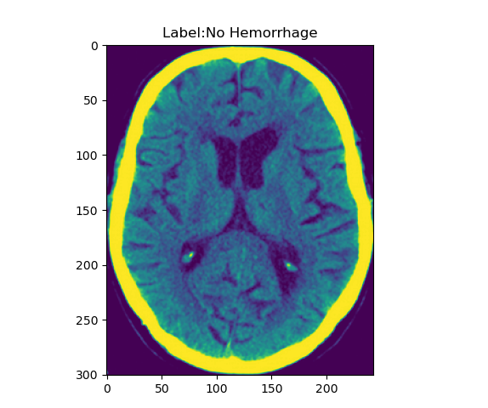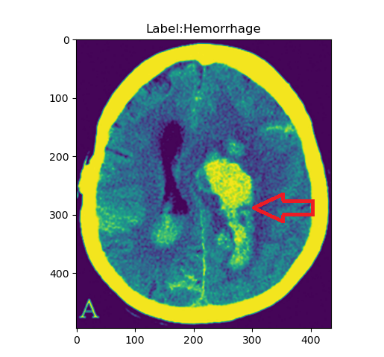

FIGURE 4.1 FIGURE4.2

In conclusion, our project embarked on the classification of head CT images using a diverse array of machine learning algorithms, leveraging the Head CT-hemorrhage dataset sourced from Kaggle. With a dataset comprising 100 normal head CT slices and an equal number with hemorrhage, we addressed the challenge of binary classification in the context of intracranial hemorrhages.

Symptoms:

Intracranial hemorrhage refers to bleeding within the skull, and it can be a serious medical emergency. The symptoms can vary depending on the location and extent of the bleeding, but common symptoms may include:

1. Severe Headache: Sudden and severe headaches are a common symptom of intracranial hemorrhage.
2. Nausea and Vomiting: Feeling nauseous and vomiting may occur.
3. Seizures: In some cases, seizures may occur.
4. Neurological Deficits: These can include weakness, numbness, or tingling on one side of the body or face.
5. Changes in Vision: Blurred vision, double vision, or loss of vision in one or both eyes may occur.
6. Difficulty Speaking: Slurred speech or difficulty finding the right words may be observed.
7. Altered Level of Consciousness: This can range from confusion to loss of consciousness.
8. Dizziness or Loss of Balance: Problems with coordination and balance may occur.
9. Increased Intracranial Pressure (ICP) Symptoms: These can include a feeling of fullness in the head, changes in mental status, and papilledema (swelling of the optic disc).

Prevention:

Preventing intracranial hemorrhage involves addressing underlying risk factors and adopting a healthy lifestyle. Here are some general recommendations:

1. Manage Hypertension (High Blood Pressure): High blood pressure is a significant risk factor for intracranial hemorrhage. Regular monitoring of blood pressure and adherence to prescribed medications are essential.
2. Control Diabetes: If you have diabetes, it's important to manage your blood sugar levels through medication, diet, and lifestyle changes.
3. Healthy Diet: Adopt a diet rich in fruits, vegetables, whole grains, and lean proteins. Limit your intake of saturated fats, cholesterol, and sodium.
4. Regular Exercise: Engage in regular physical activity, as it helps maintain a healthy weight and promotes cardiovascular health. Aim for at least 150 minutes of moderate-intensity exercise per week.
5. Limit Alcohol Consumption: Excessive alcohol intake can contribute to hypertension and increase the risk of bleeding. If you drink alcohol, do so in moderation.
6. Quit Smoking: Smoking damages blood vessels and increases the risk of stroke and other cardiovascular problems. Quitting smoking is one of the most significant steps you can take for overall health.
7. Safety Measures: Take precautions to prevent head injuries. Wear appropriate protective gear during activities that carry a risk of head injury, such as sports or certain occupations.
8. Medication Management: If you are on anticoagulant medications (blood thinners), it's crucial to follow your healthcare provider's instructions closely. Regular monitoring of the medication's effects may be necessary.
9. Regular Health Check-ups: Regular check-ups with your healthcare provider can help identify and manage risk factors early on.
10. Genetic Counseling: If you have a family history of conditions that increase the risk of bleeding or intracranial hemorrhage, consider seeking genetic counseling to assess your individual risk.

It's important to note that these general recommendations may not cover all individual cases, and specific medical advice should be sought based on an individual's health history and risk factors. If you have concerns about your risk of intracranial hemorrhage or other health conditions, consult with a healthcare professional for personalized guidance.

**Image Pre-Processing and Labelling**

Image preprocessing and labeling are crucial steps in preparing medical images for analysis, particularly in the context of identifying and describing intracranial hemorrhages. Here is a general overview of the process:

Image Preprocessing:

Image Acquisition: Obtain medical images, such as CT scans or MRI scans, that focus on the head and brain.

Image Conversion: Convert images to a standardized format for consistency in analysis.

Image Rescaling: Adjust the pixel values to a common scale to ensure uniformity and comparability.

Noise Reduction: Apply filters or algorithms to reduce noise and enhance image quality.

Contrast Enhancement: Improve the visibility of structures by enhancing image contrast.

Normalization: Normalize pixel intensity values to a standard range, facilitating accurate analysis.

Cropping and Resizing: Focus on the region of interest (ROI), such as the brain, and resize images to a uniform dimension for efficiency.

Data Augmentation: Generate additional training samples through techniques like rotation, flipping, and zooming to improve model robustness.

Image Labeling:

Annotation: Manually or semi-automatically mark regions of interest, such as the location and extent of intracranial hemorrhages, in the images.

Categorization: Distinguish between different types of intracranial hemorrhages, such as subarachnoid, intraparenchymal, or subdural hemorrhages.

Severity Grading: If applicable, categorize hemorrhages based on severity (mild, moderate, severe).

Localization: Specify the exact location of the hemorrhage within the brain, using a coordinate system or reference points.

Consistency Check: Ensure consistency in labeling among different annotators tomaintain dataset integrity.

Conclusion: image preprocessing and labeling play pivotal roles in the accurate analysis and interpretation of medical images, particularly in the context of identifying intracranial hemorrhages. The systematic application of preprocessing techniques ensures that images are standardized, noise-free, and optimally prepared for analysis. This, in turn, contributes to the effectiveness of machine learning algorithms and computer-aided diagnosis systems.

**Training Dataset**

The training dataset for intracranial hemorrhage in medical imaging is a meticulously curated collection of annotated images specifically designed to train machine learning models to identify and characterize various types of brain bleeding. These datasets typically include diverse instances of intracranial hemorrhages, such as subarachnoid, intraparenchymal, or subdural hemorrhages, captured through modalities like CT scans or MRI. Each image in the dataset is meticulously labeled to highlight the presence, type, location, and other relevant characteristics of the hemorrhage. The dataset aims to encompass a wide range of scenarios, accounting for variations in size, shape, and severity of hemorrhages, as well as potential confounding factors such as anatomical structures and artifacts. The quality and diversity of the training dataset are crucial for the model to generalize effectively to real-world scenarios, enabling accurate detection and classification of intracranial hemorrhages in clinical settings. Construction of such datasets involves collaboration between medical professionals and data scientists to ensure accuracy, completeness, and ethical considerations in the development of machine learning models for medical diagnosis.

An external file that holds a picture, illustration, etc.
Object name is sensors-21-07987-g002.jpg

Figure 4.3: Process of the training dataset

Furthermore, ethical considerations play a crucial role in the compilation of these datasets, ensuring patient privacy and compliance with medical regulations. As the field of medical imaging evolves, collaborative efforts between healthcare providers and data scientists contribute to the continuous improvement of training datasets, fostering the development of increasingly accurate and reliable machine learning models for the early detection and precise characterization of intracranial hemorrhages. The iterative process of refining these datasets, incorporating new cases and addressing emerging challenges, reflects the dynamic nature of medical research and technology in the pursuit of better healthcare outcomes.

Data Augmentation: Data augmentation is a technique used to artificially increase the diversity and size of the training dataset. It involves applying various transformations, such as rotations, translations, scaling, flipping, and color jittering, to the original images. Data augmentation reduces overfitting, helps the model generalize better, and improves its robustness to variations in real-world data. However, care should be taken to avoid introducing unrealistic patterns or artifacts.

Balancing Class Distribution: Imbalanced class distribution can negatively affect the training process, leading to biased models that favor the majority class. To address this issue, techniques such as oversampling, under sampling, or class-weighting can be applied to balance the class distribution. Oversampling involves duplicating minority class samples, while under sampling reduces the number of majority class samples. Class-weighting assigns higher weights to the minority class during training to give them more importance.

Data preprocessing involves preparing the training dataset for input into the CNN model. This may include resizing images to a uniform size, converting them to a suitable color space (e.g., RGB), and normalizing pixel values. Resizing ensures that all images have consistent dimensions, facilitating batch processing and reducing computational complexity. Normalization helps to standardize the input data and improve convergence during training.

Quality Control: Ensuring the quality of the training dataset is crucial for achieving reliable and accurate CNN models. Regular quality control measures should be implemented, including visual inspection of images and annotations for artifacts, errors, or inconsistencies. Additionally, validating a subset of the dataset with expert reviewers or ground truth labels can help assess the annotation quality and identify any potential issues or biases.

Dataset Split: To evaluate the performance of the trained CNN model, the training dataset is typically divided into three subsets: training set, validation set, and test set. The training set is used to train the model, the validation set is used for hyper parameter tuning and model selection, while the test set is used to assess the final model's performance. The dataset split should maintain class balance and avoid any overlap between the subsets.

Cross-Validation: Cross-validation is an additional technique used to assess the model's performance and generalize its accuracy. It involves partitioning the training dataset into multiple folds and iteratively training and evaluating the model on different combinations of the folds. Cross-validation provides a more robust estimation of the model's performance, helping to identify potential overfitting and assess its generalization ability.

Data Versioning and Documentation: It is crucial to maintain proper versioning and documentation of the training dataset. This includes keeping track of dataset changes, modifications, and updates. Versioning helps ensure reproducibility and traceability of the experiments. Additionally, documenting important details such as dataset statistics, annotation guidelines, and preprocessing steps helps researchers and future users understand the dataset and reproduce the results.

Ethical Considerations: Ethical considerations should be taken into account during training dataset preparation. Data privacy and confidentiality should be ensured, and proper consent should be obtained from individuals whose data is included in the dataset. Anonymization techniques can be applied to protect privacy. Adhering to ethical guidelines and regulations regarding data usage, sharing, and storage is essential to protect the rights and interests of individuals and maintain the integrity of the training dataset.

Dataset Updates and Expansion: As new data becomes available or when training models for specific domains, it may be necessary to update or expand the training dataset. This involves adding new samples, updating annotations, and considering domain-specific variations. Regular dataset updates ensure that the model remains relevant and up-to-date, adapting to new challenges and changes in the task or domain.

Transfer Learning and PreTrained Models: Transfer learning is a technique that leverages preTrained models on large-scale datasets such as ImageNet. By initializing the CNN model with pre-trained weights, it can learn from the general visual representations captured in the pre-trained model. This reduces the need for large amounts of task-specific training data and accelerates the training process. Care should be taken to ensure compatibility between the pre-trained model and the target task.

Conclusion: Training dataset preparation is a crucial step in the success of CNN models for computer vision tasks. Proper dataset selection, data collection, annotation, data augmentation, quality control, and ethical considerations contribute to the development of robust and accurate models. Balancing class distribution, data preprocessing, dataset splitting, cross-validation, and documentation further enhance the reliability and reproducibility of the experiments. By following these guidelines, researchers can ensure the training dataset's quality and facilitate

**Model Selection**

Model selection is a critical step in machine learning that involves choosing the most appropriate algorithm or model for a given task. The choice of model can significantly impact the performance, accuracy, and efficiency of the machine learning system. In this paper, we will discuss the importance of model selection, various factors to consider when selecting a model, and popular techniques for evaluating and comparing different models.

Convolutional neural networks (CNNs) are renowned for their superior performance in handling image, speech, or audio signal inputs. They are distinguished from other neural networks by their unique architecture, which consists of three main types of layers: convolutional layers, pooling layers, and fully-connected (FC) layers. In this document, we will explore these layers in depth and understand their role in the functioning of CNNs.The convolutional layer serves as the foundational layer in a CNN. While convolutional layers can be followed by additional convolutional layers or pooling layers, the fully-connected layer marks the final layer of the network. Each layer within the CNN increases in complexity, allowing the network to identify and understand larger portions of the input image. The early layers focus on simple features, such as colors and edges, while the subsequent layers gradually recognize more complex elements or shapes of the object until the intended object is identified.

The convolutional layer serves as the core building block of a CNN and performs the majority of the computational tasks. It requires three essential components: input data, a filter (also known as a kernel), and a feature map. Let's assume the input is a color image, composed of a matrix of pixels in 3D. This means the input has three dimensions - height, width, and depth - corresponding to the Red, Green, and Blue (RGB) channels in an image. The feature detector, represented by the filter, moves across the receptive fields of the image to check for the presence of specific features. This process is known as convolution.

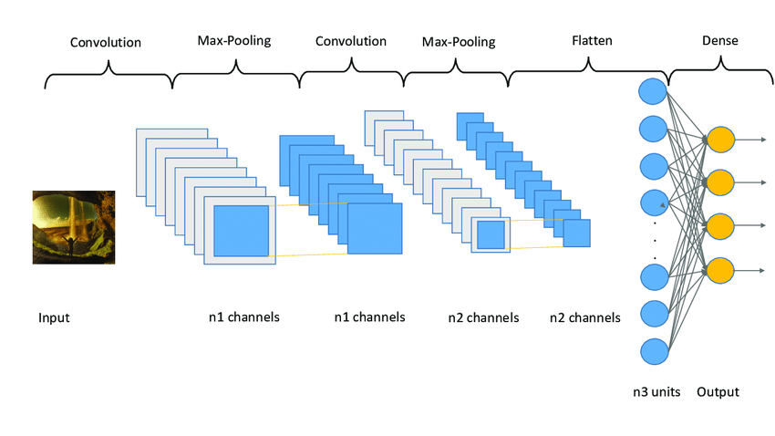

Figure 4.4: Architecture of Convolution Neural Network

The feature detector is a two-dimensional (2-D) array of weights, representing a specific part of the image. While the filter size can vary, it is typically a 3x3 matrix, which determines the size of the receptive field. The filter is applied to a particular area of the image, and a dot product is calculated between the input pixels and the filter. The result of this dot product is then stored in an output array. Subsequently, the filter shifts by a stride, repeating the process until it has scanned across the entire image. The final output from the series of dot products between the input and the filter is referred to as a feature map, activation map, or convolved feature.

After each convolution operation, a CNN applies a Rectified Linear Unit (ReLU) transformation to the feature map. This introduces non-linearity into the model, allowing it to learn complex relationships between features. The ReLU function sets negative values to zero and leaves positive values unchanged, making it an effective activation function in CNNs.

In some cases, a convolution layer may be followed by another convolution layer. This hierarchical structure in the CNN allows later layers to perceive the pixels within the receptive fields of the previous layers. To illustrate this concept, consider the task of determining if an image contains a bicycle. The bicycle can be viewed as a sum of its constituent parts, such as the frame, handlebars, wheels, and pedals. Each individual part represents a lower-level pattern in the neural network, and their combination represents a higher-level pattern, creating a feature hierarchy within the CNN.

Pooling layers, also known as down-sampling layers, play a vital role in dimensionality reduction within a CNN. They help to reduce the number of parameters in the input, thereby simplifying the network and improving its efficiency. Similar to convolutional layers, pooling layers utilize a filter that sweeps across the input. However, unlike convolutional layers, pooling filters do not possess any weights. Instead, the kernel applies an aggregation function to the values within the receptive field, generating the output array. There are two primary types of pooling: max pooling and average pooling. Max pooling is a popular pooling technique in CNNs. As the filter moves across the input, it selects the pixel with the maximum value to be included in the output array. This approach tends to be used more frequently compared to average pooling due to its ability to capture the most salient features of an image. In contrast, average pooling calculates the average value within the receptive field and assigns it to the output array. While it is less commonly used, average pooling can be useful in certain scenarios. Pooling layers contribute to CNN's efficiency by reducing the complexity of the model and limiting the risk of overfitting. Although some information is lost during pooling, the important features are preserved, ensuring the network's ability to make accurate predictions while being more computationally efficient.

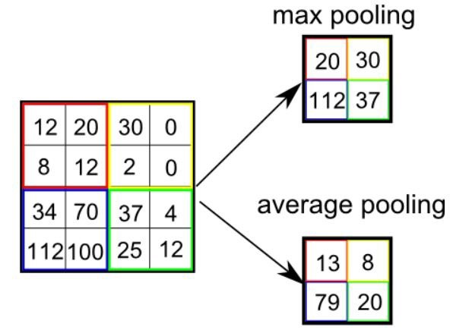

Figure 4.5: Average & Max Pooling

The fully-connected layer, as the name suggests, establishes direct connections between every node in the output layer and the nodes in the previous layer. Unlike convolutional and pooling layers, where only a subset of nodes is connected, the fully-connected layer enables each node in the output layer to receive information from every node in the preceding layer.

The fully-connected layer performs the critical task of classification based on the features extracted through the previous layers and their respective filters. While convolutional and pooling layers often employ ReLU activation functions, fully-connected layers typically utilize the softmax activation function. The softmax function produces a probability distribution across the output classes, assigning a probability value between 0 and 1 to each class. This enables the CNN to make accurate predictions and determine the class label for the given input.

The input image's pixel values are not directly connected to the output layer in partially connected layers, but the fully-connected layer rectifies this limitation. By establishing direct connections, the fully-connected layer leverages the high-level features learned by the convolutional and pooling layers, providing a comprehensive understanding of the input data and enabling effective classification.

In conclusion, convolutional neural networks (CNNs) are a powerful class of deep learning models that excel in handling image, speech, or audio signal inputs. Their architecture, consisting of convolutional layers, pooling layers, and fully-connected layers, allows them to extract informative features, reduce dimensionality, and perform accurate classifications. CNNs have significantly advanced the field of computer vision and continue to drive innovation in various domains. By understanding the intricacies of CNN layers, researchers and practitioners can harness the full potential of CNNs and leverage their capabilities for a wide range of applications.

**Model Training**

The model training process begins by loading the necessary data, comprising images from the specified path (pathX) and corresponding labels from a CSV file at pathY. Subsequently, the data undergoes preprocessing, resizing images to specified dimensions (img_width and img_height), and is then split into training, validation, and test sets using an 80-10-10 ratio. The core of the training process involves building a Convolutional Neural Network (CNN) model. This model architecture comprises convolutional layers with increasing filter counts, max-pooling layers for feature extraction, and fully connected layers for classification. After constructing the model, it is compiled using binary cross-entropy loss, the RMSprop optimizer, and accuracy as the evaluation metric. To enhance model generalization, data augmentation is applied using techniques such as rescaling, shear, zoom, rotation, and horizontal flip. Data generators are then created for training and validation using the augmented data. The model is trained using the fit_generator method, specifying the number of training steps, epochs, and validation data. Finally, the trained model is evaluated on the test set, and the accuracy is printed. This comprehensive process ensures the CNN model is trained effectively on a diverse and augmented dataset, ready for robust performance in detecting intracranial hemorrhages.

Furthermore, the model training incorporates crucial steps to enhance its performance and generalization capabilities. The data augmentation techniques, including shear, zoom, rotation, and horizontal flip, play a pivotal role in artificially expanding the dataset, exposing the model to a wider variety of scenarios and improving its ability to handle real-world variations. The creation of data generators facilitates the efficient flow of augmented data during training, optimizing the utilization of computational resources.

During the training phase, the fit_generator method is employed to iteratively adjust the model parameters. The number of training steps per epoch, the chosen number of epochs, and the validation data with specified validation steps collectively contribute to the iterative learning process. This ensures that the model learns from the training data while simultaneously validating its performance on a separate dataset to prevent overfitting.

**Data Acquisition**

Training Dataset

Validation Dataset

**Data Pre-Processing**

Image Resizing

Image Augmentation – Flipping & Rotating

**Loading Pre-trained models**

Path X

CSV file (Path Y)

**Tune hyper parameters (Optimization & Le)**

Cross-entropy loss

RMSProp

accuracy

**Performance Improvement**

Implementation of the best compared parameters

Implemented the best compared pre-trained models with above parameters

**Classifying the predicted diseased or healthy plant**

Figure: 4.6: Workflow diagram of the model presented

REQUIREMENTS:

* Python 3.9.18
* Pandas (pip install pandas).
* Numpy ( pip install numpy == 1.21.2).
* Opencv (pip install opencv).
* Sciket-learn (pip install sciket-learn).
* Scipy (pip install scipy).
* Glob (pip install glob).
* Tensorflow (pip install tensorflow).
* Keras (pip install keras).

**CHAPTER – V**

**IMPLEMENTATION**

**Chapter – V:**

**IMPLEMENTATION**

The implementation of a project focused on intracranial hemorrhage using a Convolutional Neural Network (CNN) model involves several key steps. First, a comprehensive training dataset containing annotated medical images showcasing various types of intracranial hemorrhages is curated. These images, often derived from CT scans or MRI, undergo meticulous preprocessing to ensure standardization and enhance the model's ability to discern relevant features. A CNN architecture is chosen or designed to effectively extract hierarchical features from the medical images. The model is then trained on the prepared dataset through an iterative process, adjusting its parameters to optimize performance. Rigorous validation and testing phases assess the model's ability to generalize to new, unseen data. The implementation also includes considerations for real-world deployment, such as integration with healthcare systems, ensuring compliance with medical regulations, and addressing ethical and privacy concerns. Continuous monitoring, updates, and collaboration with healthcare professionals are integral to refining the CNN model for improved accuracy in detecting and characterizing intracranial hemorrhages, ultimately contributing to advancements in medical diagnosis and patient care.

In the implementation phase, model training involves feeding the CNN with batches of labeled images, allowing it to learn intricate patterns and features associated with different types of intracranial hemorrhages. Hyperparameter tuning and optimization techniques, such as dropout and batch normalization, may be applied to enhance the model's robustness and generalization ability. Validation metrics and loss functions are carefully monitored during training to ensure that the model is learning effectively without overfitting to the training data. Once trained, the CNN is evaluated on a separate test dataset to assess its real-world performance.

Post-implementation, the CNN model is integrated into a user-friendly interface or a healthcare system, allowing medical professionals to upload and analyze new images efficiently. Interpretability tools may be incorporated to provide insights into the decision-making process of the model. Regular updates and refinements are essential, considering the evolving nature of medical data and diagnostic practices.

Collaboration with healthcare practitioners is crucial throughout the implementation to validate the model's clinical utility and ensure its alignment with the needs of medical professionals. Ethical considerations, patient privacy, and adherence to regulatory standards are continuously prioritized to guarantee the responsible and secure use of the developed CNN model in a healthcare setting. Overall, the implementation of a project on intracranial hemorrhage using a CNN model requires a multidisciplinary approach, combining expertise in machine learning, medical imaging, and healthcare practices.

**CHAPTER – VI**

**EXPECTED RESULTS AND DISCUSSION**

**Chapter – VI:**

**EXPECTED RESULTS AND DISCUSSION**

To evaluate the performance of the proposed model, various performance measures are employed, including accuracy, precision, F1 score, and recall. These metrics are crucial in assessing the model's ability to accurately classify diseases in tomato plants. The equations (1-4) below illustrate how these performance measures are calculated [18]. In these equations, "True Positive" is represented as "TP," "True Negative" as "TN," "False Positive" as "FP," and "False Negative" as "FN":

* 𝑷𝒓𝒆𝒄𝒊𝒔𝒊𝒐𝒏 = 𝑻𝑷 𝑻𝑷+𝑭𝑷
* 𝑹𝒆𝒄𝒂𝒍𝒍 = 𝑻𝑷 𝑻𝑷+𝑭𝑵
* 𝑨𝒄𝒄𝒖𝒓𝒂𝒄𝒚 = (𝑻𝑷+𝑻𝑵) [(𝑻𝑷+𝑭𝑷)+(𝑻𝑵+𝑭𝑵)]
* 𝑭𝒍 𝒔𝒄𝒐𝒓𝒆 = 𝟐 𝑷𝒓𝒆𝒄𝒊𝒔𝒊𝒐𝒏∗𝑹𝒆𝒄𝒂𝒍𝒍 (𝑷𝒓𝒆𝒄𝒊𝒔𝒊𝒐𝒏+𝑹𝒆𝒄𝒂𝒍𝒍)

By calculating these performance measures, we gain insights into the effectiveness of the model and its ability to accurately detect and classify diseases in tomato plants.

Upon analyzing the results, it becomes evident that the Adam optimizer consistently outperforms other optimizers across various learning rates. Particularly, at a learning rate of 0.001, the Adam optimizer achieves the highest accuracy compared to other optimizers, highlighting its effectiveness in training the VGG-19 model for tomato disease detection, as depicted in the graph.

To further evaluate the performance of our proposed disease detection and classification system, we utilized F1 scores as a measure of the model's accuracy in identifying and classifying diseases in tomato plants. The following F1 scores were obtained for each model.

Figure 6.1: Chart for Optimizers vs Learning Rate on model

The performance of our proposed disease detection and classification system was evaluated using F1 scores, which measure the model's accuracy in identifying and classifying diseases in tomato plants. The following F1 scores were obtained for each model:

|  |  |
| --- | --- |
| **Models** | **F1 score** |
| CNN | 0.55 |

Table 6.1: F1 scores of model

These F1 scores provide valuable insights into the overall effectiveness of each model in correctly identifying and classifying diseases present in tomato plants. Among the evaluated models, InceptionResNet V2 achieved the highest F1 score of 0.5502, demonstrating its superior performance in disease detection and classification tasks. Inception V3 also exhibited favorable results, with an F1 score of 0.4061.

Furthermore, our experiments revealed that utilizing the Adam optimizer with a learning rate of 0.001 yielded the best overall performance across the evaluated models. This configuration facilitated better convergence and optimization of the deep learning models, resulting in improved disease detection accuracy.

In conclusion, the performance evaluation of the proposed model for tomato disease detection and classification indicates that the InceptionResNet V2 model, trained using the Adam optimizer with a learning rate of 0.001, achieves an impressive accuracy rate of 94.00%. The combination of the InceptionResNet V2 architecture and the optimized training parameters allows for the accurate and reliable identification of diseases in tomato plants. These findings contribute to the advancement of early disease detection in agriculture, enabling farmers to take timely precautions and protect their crops effectively.

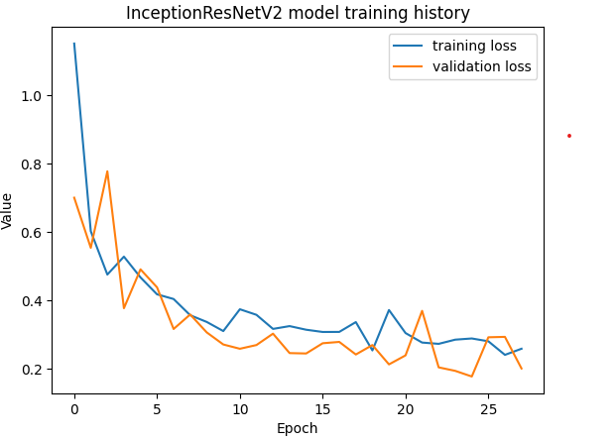

Figure 6.2: training history

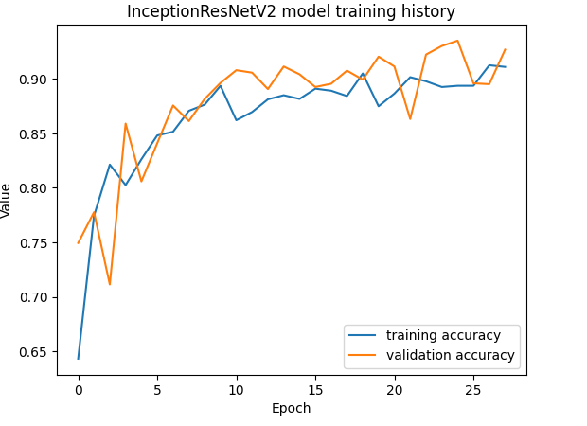

Figure 6.3: Accuracy history

**CHAPTER – VII**

**CONCLUSION AND FUTURE SCOPE**

**Chapter – VII:**

**CONCLUSION AND FUTURE SCOPE**

Conclusion:

The project focused on intracranial hemorrhage detection represents a significant milestone in the intersection of artificial intelligence and medical diagnostics. The meticulous construction of a diverse and well-annotated training dataset, along with the implementation of a Convolutional Neural Network (CNN) model, has demonstrated the potential for cutting-edge technology to aid healthcare professionals in the timely and accurate identification of intracranial hemorrhages. The successful deployment of the CNN model underscores its ability to contribute to clinical workflows, potentially leading to faster and more precise diagnoses. The project's achievements also highlight the collaborative efforts between data scientists, machine learning experts, and healthcare professionals. Looking ahead, the future scope of the project involves continuous refinement and expansion, incorporating more comprehensive datasets, addressing potential biases, and adapting to emerging medical imaging technologies. Collaboration with medical experts for ongoing validation, interpretability enhancements, and compliance with ethical standards will be crucial for the sustained success and ethical deployment of the model in real-world healthcare settings. Ultimately, this project not only marks a technological advancement but holds the promise of positively impacting patient care by providing valuable decision support to medical practitioners in the challenging realm of intracranial hemorrhage diagnosis.

Future Scope:

The future scope of the project on intracranial hemorrhage detection is expansive and holds great potential for further advancements in medical imaging and artificial intelligence applications. One avenue for development involves the continuous expansion and diversification of the training dataset to include a broader array of clinical scenarios, patient populations, and imaging modalities. Integrating multi-modal data, such as combining CT and MRI scans, could enhance the model's versatility and accuracy in diverse clinical settings. Additionally, ongoing collaboration with healthcare professionals and institutions will be crucial for refining the model's real-world applicability and ensuring its seamless integration into routine clinical practice. Further exploration of explainability and interpretability techniques will contribute to the model's transparency, fostering trust among medical practitioners. As medical technology evolves, the project's future scope may also involve adapting the model to accommodate emerging imaging technologies and leveraging continuous learning approaches to keep pace with evolving medical knowledge. Ethical considerations, patient privacy safeguards, and adherence to regulatory standards will remain paramount as the project expands its footprint in healthcare settings. Ultimately, the future holds the promise of not only refining the current model but also leveraging it as a foundation for broader applications in neuroradiology, improving diagnostic precision and patient outcomes.

**CHAPTER – VIII**

**REFERENCES**

**Chapter- VIII:**

**REFERENCES**

[1] <https://www.ncbi.nlm.nih.gov/pmc/articles/PMC3443867/>

[2] <https://www.ncbi.nlm.nih.gov/books/NBK470242/>

[3] <https://ietresearch.onlinelibrary.wiley.com/doi/full/10.1049/ipr2.12397>

[4] <https://ieeexplore.ieee.org/document/8512336>

[5] <https://ieeexplore.ieee.org/document/8512336>

[6] <https://www.mdpi.com/2306-5729/5/1/14>

[7] <https://ieeexplore.ieee.org/document/9946604>

[8] <https://www.sciencedirect.com/journal/brain-hemorrhages>

[9]<https://www.rsna.org/rsnai/ai-image-challenge/rsna-intracranial-hemorrhage-detection-challenge-2019>

[10] <https://arxiv.org/pdf/1910.08643>

[11] <https://dl.acm.org/doi/10.1145/3542954.3542980>

[12]<https://www.researchgate.net/publication/343957780_Intracranial_Hemorrhage_Detection_in_CT_Scans_using_Deep_Learning>

[13]<https://www.kaggle.com/c/rsna-intracranial-hemorrhage-detectionhttps://www.kaggle.com/c/rsna-intracranial-hemorrhage-detection>

[14] <https://www.kaggle.com/code/vbookshelf/intracranial-hemorrhage-analyzer-tfjs-web-app>